Phone Book Report  
-declaring structure name contact that contain all information of each contact that each one is array of char:first name,last name,phone number,email,address and inside this struct there is another struct for date of birth int type consists of day,month,and year.

-initializing a global array of struct named c with size 1000 to save maximum number of 1000 contact and initializing a global variable named count=0 to count the number of contact that will be saved.

**-main**will print a menu and ask user every time with a do while loop to select an option by switch case and call a function in each case.  
case 1 load contacts case 5 print contacts sorted  
case2 add a contact case 6 delete a contact case3 search case 7 save   
case 4 modify case 8 exit the program  
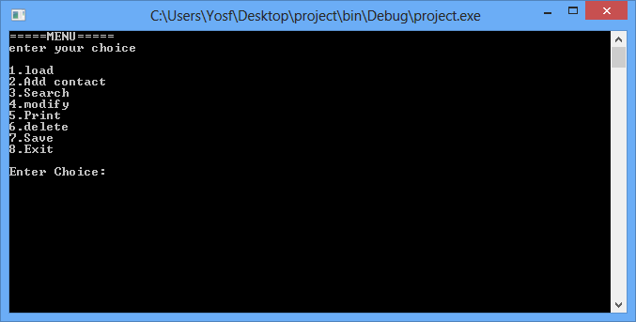

**- load**  
this function read all information of contact from a file and save them in the global array of struct by first open the file then loop and in each pass of loop the global variable count increase by 1 as counting the number of contacts and save information of contacts until end of file then close the file.

**-add**this function add a new contact by initializing a variable of struct named con and scanning all information of new contact: first name, last name, address, phonenumber,email and check it is a valid email or not and scan until user enter valid email ,and date of birth(day,month,year) and also check that the user enter a valid date of birth or not and scan it until user enter valid birthdate and then put all these information in the array of struct to be last element in the array and then increment count by 1 as number of contacts increase by new one.

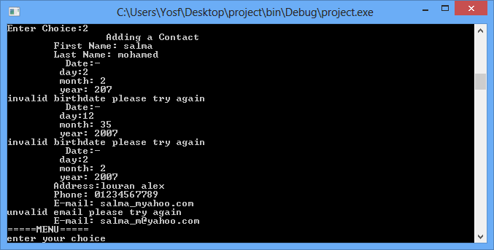

**-void search()**this function allow the user to search for a contact by contact’s last name by scanning the last name he wants to search then using linear search by loop until count(the number of contacts) compare this name by all contacts last name by strcasecmp function from string.h library and print all contacts information with same last name and print the number of contacts found with same last name and if contact can’t find print to user error.

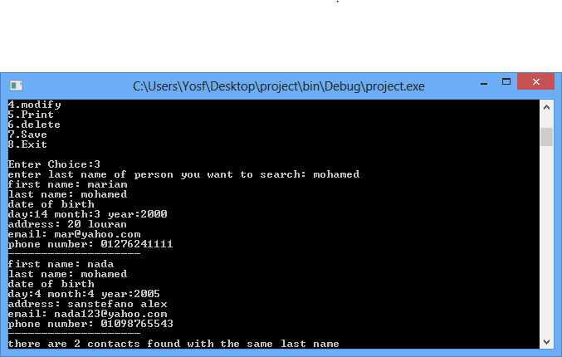

**-void modify()**  
allow user to modify anything in contact information by scanning last name of contact he want to modify then compare the last name of contact with the last name of all contacts and every contact found ask the user he want to modify this contact or search again if the user want to modify this contact ask what he want to modify by switch case. 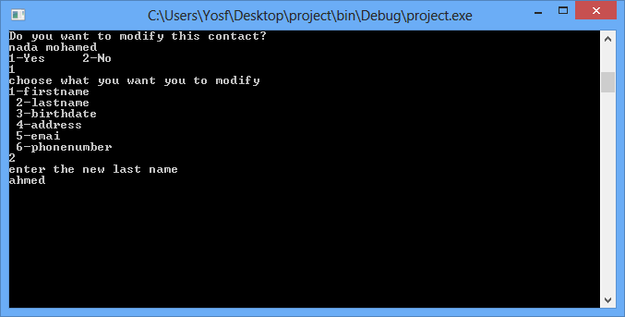

**-printsorted**this function print all contacts in the array of struct and sort them by any method user choose   
1-sort by last name 2-sort by date of birth  
  
  
1- if user choose sort by last name method the function will be called and **sort by bubble sort method**  works by repeatedly swapping the adjacent elements if they are in wrong order by compare last name by strcasecmp to be sorted alphabetically.

2-if user choose sort by date of birth method it will be called and **also sort by bubble sort** works by repeatedly swapping the adjacent elements if they are in wrong order to make contact sort from youngest contact to oldest by checking 3 conditions.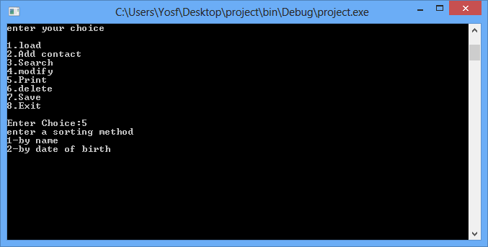

**-void delete()**this function allow user to delete any contact he want by scanning contact first and last name and comparing them with all contacts by strcasecmp and then if program find contact ask user to be sure and if program can’t find the contact print to user can’t find contact.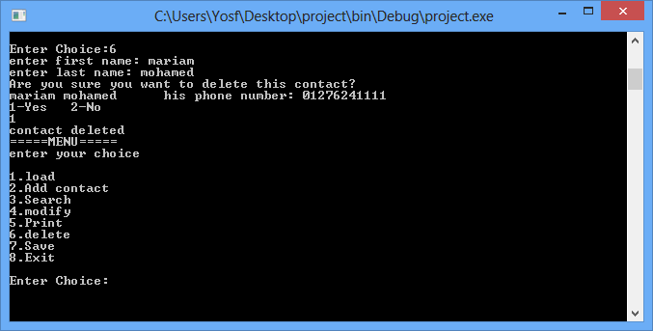

**-void save()**  
this function allow user to save all his work in a file in writing mode by deleting everything in file and write new information that are in array of struct.

**-void quit()**this function allow user to exit the program by asking user do you want to exit the program if he choose yes program will exit if he choose no it will return to main to choose an option 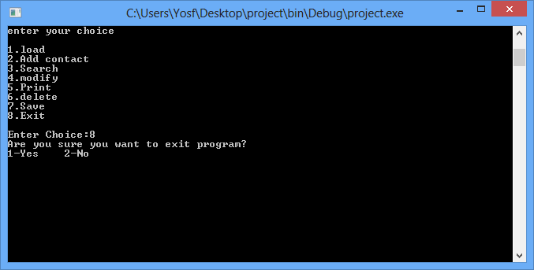

**-User’s guide:**

A menu displayed to choose any option



**-first choice load** provide to you loading your contacts from file by writing number 1.  
**-second choice add contact** provide to you adding a new contact by writing number 2.  
1-write contact’s first name  
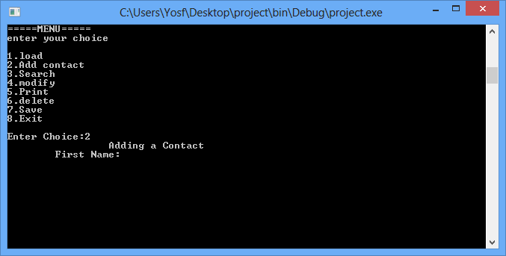

2-write contact’s lastname  
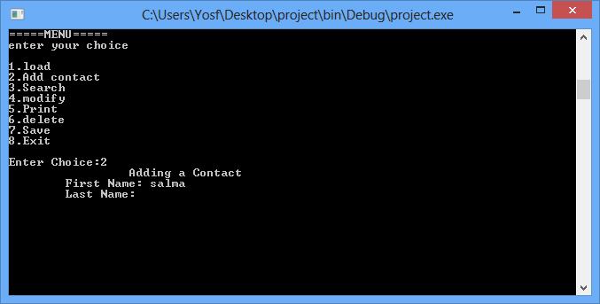  
3-write contact’s date of birth and be sure it is a valid date  
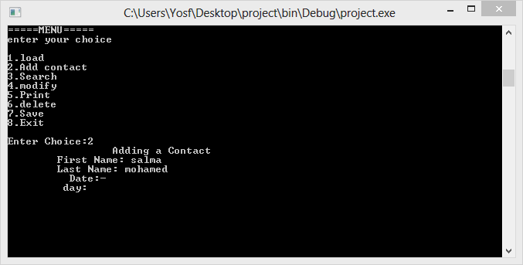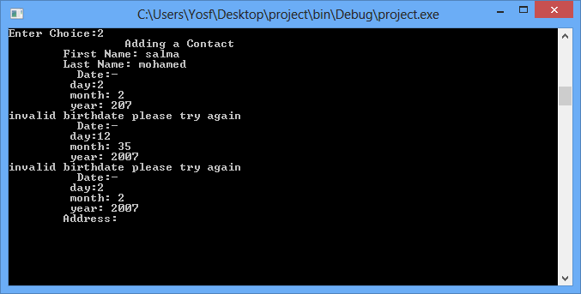4-write contact’s address  
 5-write contact’s phone number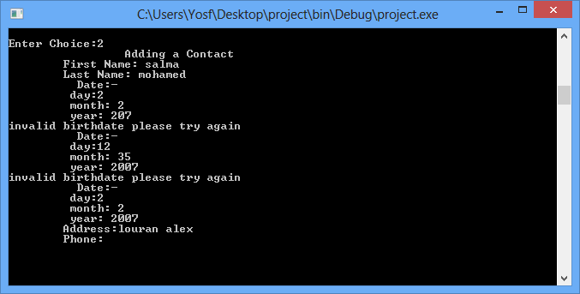  
6-write contact’s email and be sure it is valid email

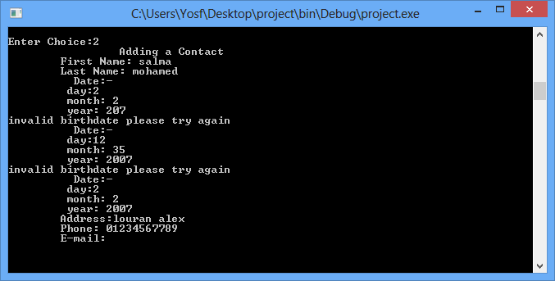

**-third choice search** provide to you searching for a contact by entering contact’s lastname and it prints all contacts with matching lastname and prints the number of contacts found and if no contact found it tells you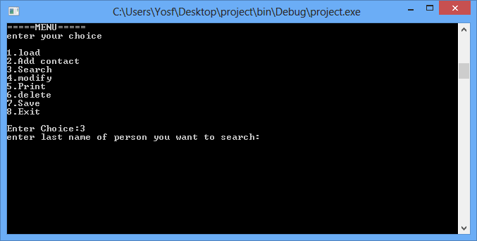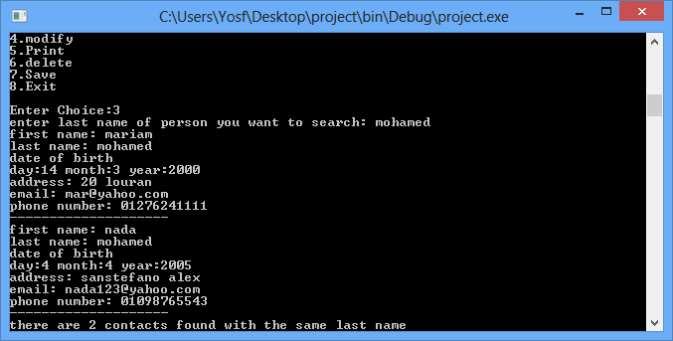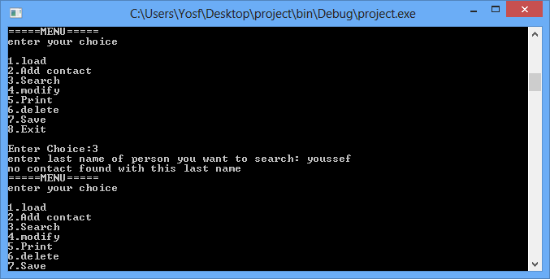

**-fourth choice modify** provides to you modifying any information of contact and ask you which contact you want to modify.  
-write contact’s lastname you want to modify

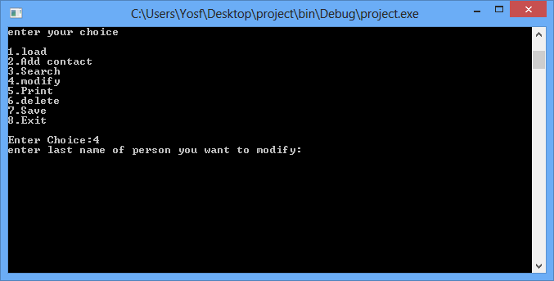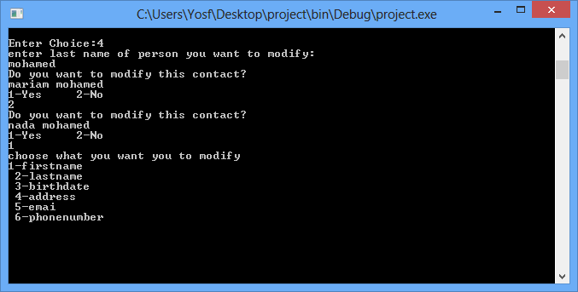 program will show you all contacts with same last name and you should press 1 if you want to modify this contact or press 2 if you don’t want to modify this contact and then if you press 1 you should choose what you want to modify in the contact by choosing from 1 to 6   
case 1 modifying first name  
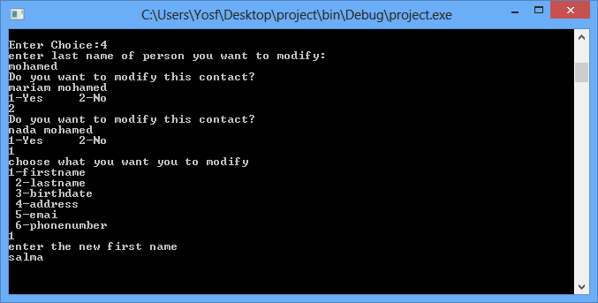

Case2 modifing last name Case 3 modifying birthdate you should enter a valid date of birth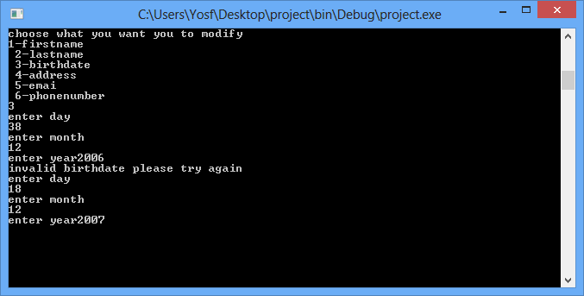 Case 4 modifying address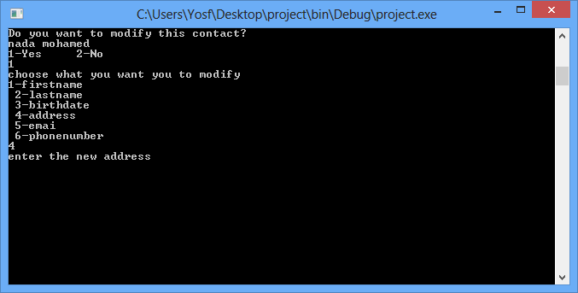

Case5 modifying email you should enter a valid email (email shouldn’t contain any space)(ex:example@domain.com)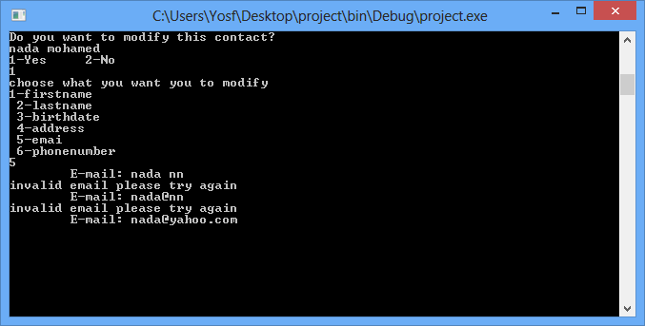 case 6 modifying phonenumber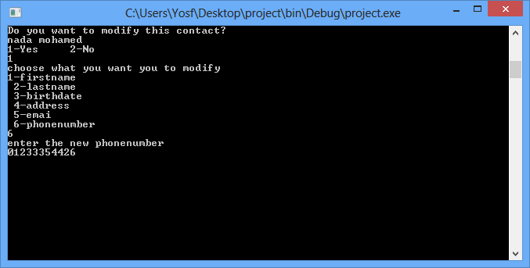 **-fifth choice print** provides to print all contact sorted by choosing sort by last name or sort by date of birth

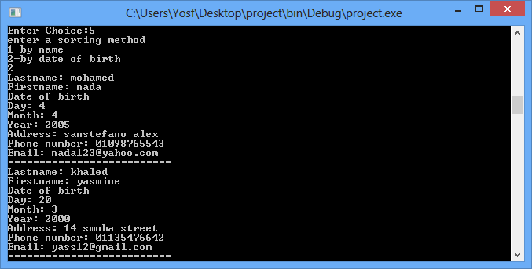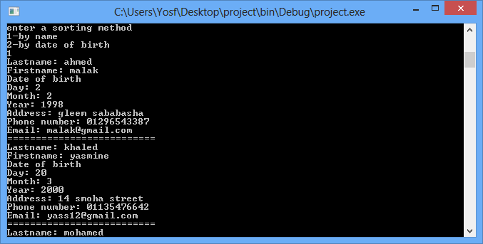**sixth choice delete** provides to delete contact by writing contact’s first and last name and if program find contact ask you to be sure**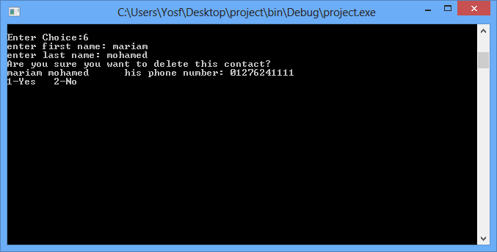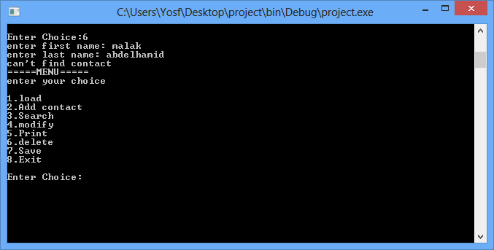  
Seventh choice save** this will save all your work and put contacts in file.

**last choice exit** by choosing number 8 this will exit your program

